**Hello Team!** **Consider the below two tables**:

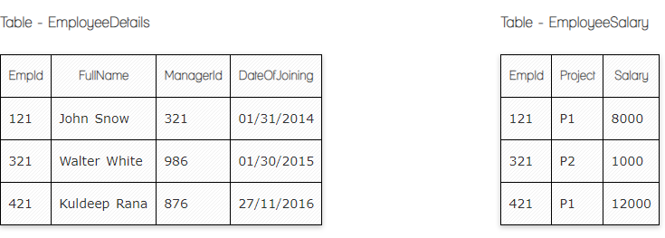

**Ques.1. Write a SQL query to fetch the count of employees working in project 'P1'.**

**Your Answer:**

**Select Count (EmpId), Project**

**From EmployeeSalary**

**Group by Project**

**Having count (Project) = ‘P1‘**

**Ques.2. Write a SQL query to fetch employee names having salary greater than or equal to 5000 and less than or equal 10000.**

**Your Answer:**

**Select Fullname**

**FROM EmployeeDetails**

**Where EmpID=**

**(Select EmpID**

**From EmployeeSalary**

**Where Salary BETWEEN 5000 And 10000)**

**Ques.3. Write a SQL query to fetch count of employees sorted by project's count in descending order.**

**Your Answer:**

**Select Count (EmpId), Project**

**From EmployeeSalary**

**Group by Project**

**Order by (Project) DESC**

**Ques.4. Write a query to fetch employee names and salary records. Return employee details even if the salary record is not present for the employee.**

**Your Answer:**

**Select EmployeeDetails. FullName, EmployeeSalary.Salary**

**From EmployeeDetails**

**Left Join EmployeeSalary ON EmployeeDetails. EmpID=EmployeeSalary.EmpID**

**Ques.5. Write a SQL query to create an empty table with ‘Test’ name.**

**Your Answer:**

**CREATE TABLE Test**

**Ques.6. Write a SQL query to delete an empty table with ‘Test’ name.**

**Your Answer:**

**DROP TABLE TEST**

**Ques.7. Write a SQL query to fetch all the Employees details from EmployeeDetails table who joined in Year 2016.**

**Your Answer:**

**SELECT \***

**FROM EmployeeDetails**

**WHEN Date of joining like ‘%2016’**

**Ques.8. Write a SQL query to insert new record to the EmployeeDetails table with any data.**

**Your Answer:**

**Insert into EmployeeDetails (EmpId, Full name, ManagerId, Date of joining)**

**Values (111, ‘John White’, 222, 02/01/2020)**

**Ques.9. Write a SQL query to update EmployeeSalary table with setting Salary to 2000 for Project P2.**

**Your Answer:**

**Update EmployeeSalary**

**Set Salary = 2000**

**Where Project= ’P2’**

**Ques.10. Write a SQL query to right join both tables and draw the results.**

**(ՀԱստատ սխալ եմ գրել☹)**

**Your Answer:**

**Select EmployeeDetails.*, EmployeeSalary.\***

**From EmployeeDetails**

**Right Join EmployeeSalary ON EmployeeDetails. EmpID=EmployeeSalary.EmpID**

|  |  |  |  |  |  |
| --- | --- | --- | --- | --- | --- |
| **EmpID** | **Project** | **Salary** | **FullName** | **ManagerID** | **DateofJoining** |
| **121** | **P1** | **8000** | **John Snow** | **321** | **01/31/2014** |
| **321** | **P2** | **1000** | **Walter White** | **986** | **01/30/2015** |
| **421** | **P1** | **12000** | **Kuldeep Rana** | **876** | **27/11/2016** |

**Now take these two tables:**

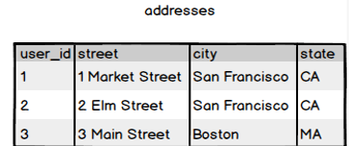

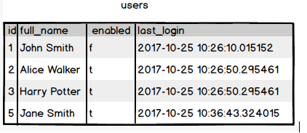

**Ques.11. Write a SQL query to fetch all users full_name from San Francisco.**

**Your Answer:**

**Select addresses.city, users.full_name**

**From Addresses**

**Inner Join Users ON addresses.user_id=users.id**

**Where Addresses.city = San Francisco**

**Ques.12. Write a SQL query to fetch all users full_name, last_login who are enabled**

**Your Answer:**

**Select full_name, last_login**

**From Users**

**Where enabled = ‘T’**

**Ques.13. Write a SQL query to fetch all users full_name who are not from Main street**

**Your Answer:**

**Select addresses.city, users.full_name**

**From Addresses**

**Inner Join Users ON addresses.user_id=users.id**

**Where NOt Addresses.city = ‘Main Street’**

**Ques.14. Write a SQL query to fetch all users full_name who are from Main street or San Francisco**

**Your Answer:**

**Select users.full_name, addresses.city**

**From Users**

**Inner Join Addresses ON users.ID=Addresses.user.ID**

**Where Addresses.street IN (‘Main street’, ‘San Francisco’**

**)**

**Ques.15. Write a SQL query to fetch user full_name who is equal to user_id from Boston (find user_id value in sub_query)**

**Your Answer:**

**Select Full_name**

**From User**

**Where UserID=**

**(Select UserID**

**From Addresses**

**Where city= ’Boston’)**